SWT 22022 – Practical for Internet Application Development
Department of Information and Communication Technology
Faculty of Technology
Lab sheet :03
Reg. Number: SEU/IS/20/ICT/084
Academic Year :2020/2021
Date: 2024.06.18
Practical No :03

Title:
- Introduction to Database and MySQL (OOP).

Aims:
- Setting up a MySQL database
- Writing SQL queries for CRUD operations
- Basic Page

Tasks:
- Create database in MySQL
- Build the connection with PHP
- Create / Store data in MySQL database using PHP
- Read data in MySQL database using PHP
- Update in MySQL database using PHP
- Delete in MySQL database using PHP
Activities :
- Create database in MySQL

CREATE DATABASE facility;

USE facility;

CREATE TABLE students (
Name varchar(255) NOT NULL,
Gpa decimal(4,3) NOT NULL,
ID int(10) NOT NULL PRIMARY KEY AUTO_INCREMENT
);

- Implement connection

private function connect(){
$this->connection = mysqli_connect($this->host, $this->username, $this>password, $this->database);

if (!$this->connection) {
die("Connection Failed: " . mysqli_connect_error());
}

- Read Operation

public function getAllStudents(){
$query = "select * from `students`";
$result = mysqli_query($this->connection, $query);
if (!$result) {
die("Failed to retrieve data");
}
$students = [];
while ($row = mysqli_fetch_assoc($result)) {
$students[] = $row;
}
return $students;
}

- Create / Store / Insert Operation

public function create(){
if (empty($this->name) || empty($this->gpa)) {
return header('location:index.php?error=All fields are required');
}
$query = "insert into `students` (`name`,`gpa`) values('$this>name', '$this->gpa')";
$result = mysqli_query($this->connection, $query);
if (!$result) {
return header('location:index.php?error=Failed to add student');
}
return header('location:index.php?success=Successfully added student');
}

- Update Operation
- Read specific student
public function read(){
$query = "select * from `students` where `id` = '$this->id'";
$result = mysqli_query($this->connection, $query);
if (!$result) {
return false;
}
$row = mysqli_fetch_assoc($result);
$this->setId($row['id']);
$this->setName($row['name']);
$this->setGpa($row['gpa']);
return true;
}
- Update the student data

public function update(){
if (empty($this->id) || empty($this->name) || empty($this->gpa)) {
return header('location:index.php?error=All Fields are required');
}
$query = "update `students` set `name` = '$this->name',gpa` = '$this->gpa' where `id` = '$this->id'";
$result = mysqli_query($this->connection, $query);
if (!$result) {
return header('location:index.php?error=Failed updatedstudent data');
}
return header('location:index.php?success=Successfullyupdated student data');
}

- Delete operation
public function delete(){
$query = "delete from `students` where `id` = '$this->id'";
$result = mysqli_query($this->connection, $query);
if (!$result) {
return header('location:index.php?error=Failed to delete student');
}
return header('location:index.php?success=Successfully deleted student');
}

- Add some CSS to the web page using Bootstrap

index.php

<?php
include('DatabasesConnection.php');
require_once('Students.php');

$db = new DatabasesConnection("localhost", "root", "", "faculty");
$connection = $db->getConnection();

$student = new Student($connection);
$students = $student->getAllStudent();

if (isset($_GET['ID']) && isset($_GET['to_delete'])) {
$student->setId($_GET['ID']);
$student->delete();
}
?>

<!DOCTYPE html>
<html lang="en">
<head>
<link href="https://cdn.jsdelivr.net/npm/bootstrap@5.3.3/dist/css/bootstrap.min.css" rel="stylesheet" integrity="sha384-QWTKZyjpPEjISv5WaRU9OFeRpok6YctnYmDr5pNlyT2bRjXh0JMhjY6hW+ALEwIH" crossorigin="anonymous">
<title>Faculty Student Details</title>
</head>
<body>
<div class="container-md">
<div class="col-10 mb-3">

<form class="form-control bg-light p-4" action="index.php" method="post">
<div class="mb-3">
<label for="name" class="form-label">Name</label>
<input class="form-control form-control-lg" type="text" id="name" name="name" placeholder="Enter your Name">
</div>
<div class="mb-3">
<label for="gpa" class="form-label">GPA</label>
<input class="form-control form-control-lg" type="text" id="gpa" name="gpa" placeholder="Enter your GPA">
</div>
<input type="submit" value="Add" name="add_student" class="btn btn-primary">
</form>
<div>

<?php
if (isset($_POST['add_student'])) {
$name = $_POST['name'];
$gpa = $_POST['gpa'];
$student->setName($name);
$student->setGpa($gpa);
$student->create();
}
?>

<?php
if (isset($_GET['error'])) {
echo "<div class='alert alert-danger mt-3'>" . $_GET['error'] . "</div>";
}?>

<div class="col-10 mb-3 mt-4">
<table class="table table-bordered table-striped">
<thead class="table-dark">
<tr>
<th>ID</th>
<th>Name</th>
<th>GPA</th>
<th>Actions</th>
</tr>
</thead>
<tbody>
<?php foreach ($students as $std): ?>
<tr>
<td><?php echo $std['ID']; ?></td>
<td><?php echo $std['Name']; ?></td>
<td><?php echo $std['Gpa']; ?></td>
<td><a href="index.php?ID=<?php echo $std['ID']; ?>&to_delete=1" class="btn btn-danger btn-sm">Delete</a></td>
</tr>
<?php endforeach; ?>
</tbody>
</table>
</div>
</div>

<script src="https://cdn.jsdelivr.net/npm/bootstrap@5.3.3/dist/js/bootstrap.bundle.min.js" integrity="sha384-YvpcrYf0tY3lHB60NNkmXc5s9fDVZLESaAA55NDzOxhy9GkcIdslK1eN7N6jIeHz" crossorigin="anonymous"></script>
</body>
</html>

DatabasesConnection.php

<?php

class DatabasesConnection
{
private $host;
private $username;
private $password;
private $database;
private $connection;

public function __construct($host, $username, $password, $database)
{
$this->host = $host;
$this->username = $username;
$this->password = $password;
$this->database = $database;

$this->connect();
}

private function connect()
{
$this->connection = mysqli_connect($this->host, $this->username, $this->password, $this->database);
if (!$this->connection) {
die("Server error");
}
}

public function getConnection()
{
return $this->connection;
}
}
?>

Students.php

<?php
class Student
{
private $name;
private $gpa;
private $id;
private $connection;

public function __construct($connection)
{
$this->connection = $connection;
}

public function setName($name)
{
$this->name = $name;
}

public function setGpa($gpa)
{
$this->gpa = $gpa;
}

public function setId($id)
{
$this->id = $id;
}

public function getName()
{
return $this->name;
}

public function getGpa()
{
return $this->gpa;
}

public function getId()
{
return $this->id;
}

public function getAllStudent()
{
$query = "SELECT * FROM students";
$result = mysqli_query($this->connection, $query);
if (!$result) {
die("Failed to retrieve data!");
}
$students = [];
while ($row = mysqli_fetch_assoc($result)) {
$students[] = $row;
}
return $students;
}

public function create()
{
if (empty($this->name) || empty($this->gpa)) {
return header('Location: index.php?error=All fields are required');
}
$query = "INSERT INTO students (Name, Gpa) VALUES (?, ?)";
$stmt = mysqli_prepare($this->connection, $query);
mysqli_stmt_bind_param($stmt, 'sd', $this->name, $this->gpa);

if (mysqli_stmt_execute($stmt)) {
return header('Location: index.php?success=Successfully added student');
} else {
return header('Location: index.php?error=Failed to add student');
}
}

public function delete()
{
if (empty($this->id)) {
return header('Location: index.php?error=ID is required');
}
$query = "DELETE FROM students WHERE ID = ?";
$stmt = mysqli_prepare($this->connection, $query);
mysqli_stmt_bind_param($stmt, 'i', $this->id);

if (mysqli_stmt_execute($stmt)) {
return header('Location: index.php?success=Successfully deleted student');
} else {
return header('Location: index.php?error=Failed to delete student');
}
}
}

?>

OUTPUT :

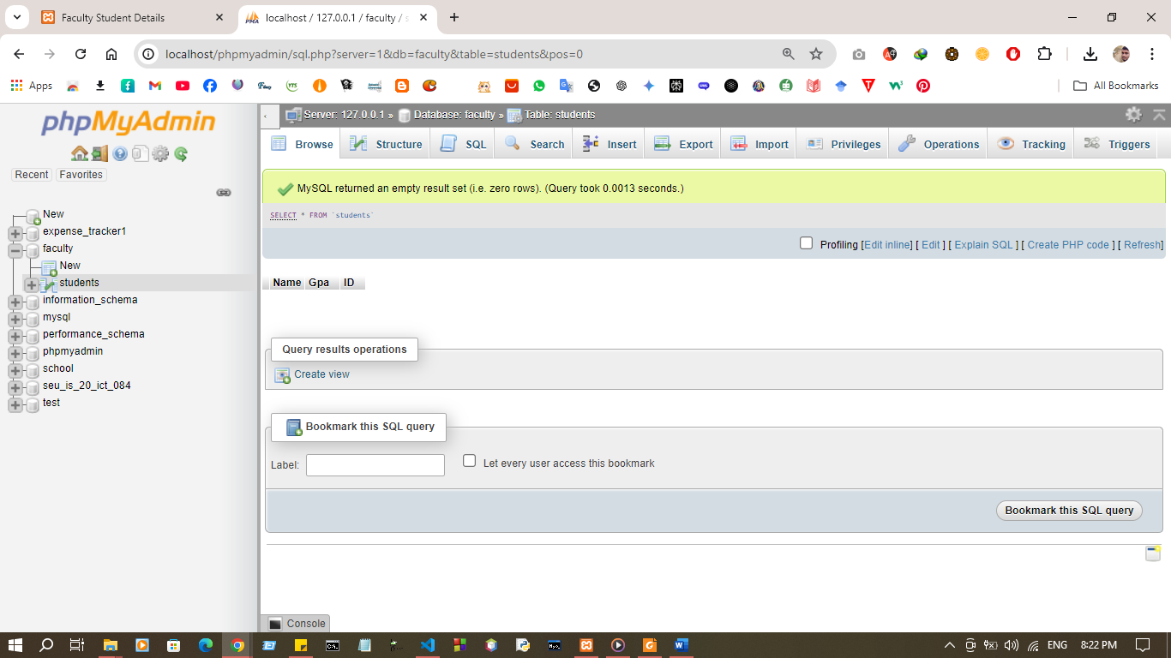

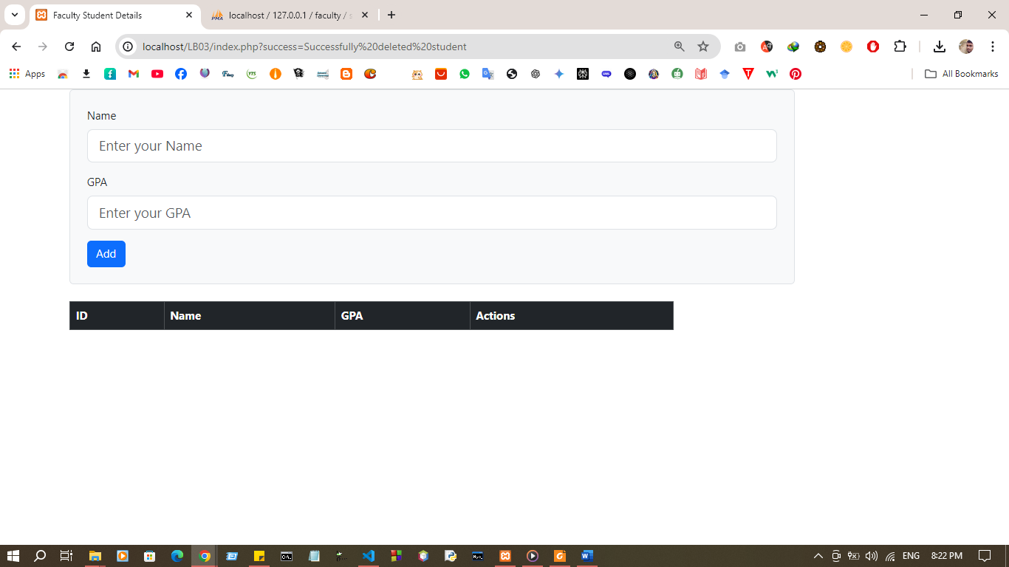

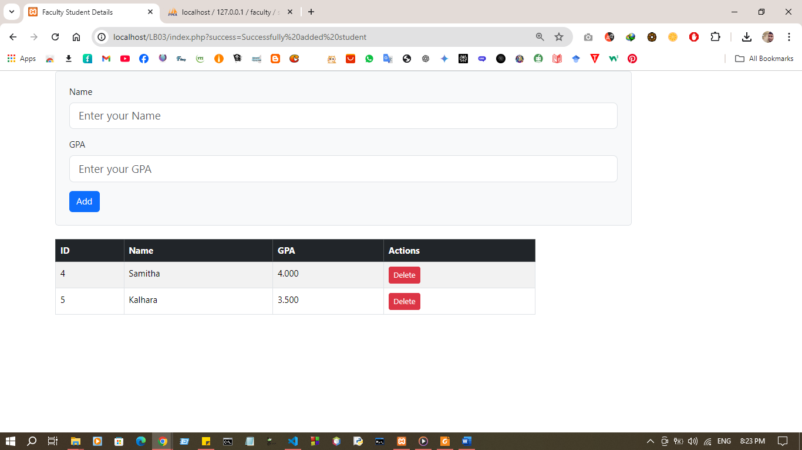
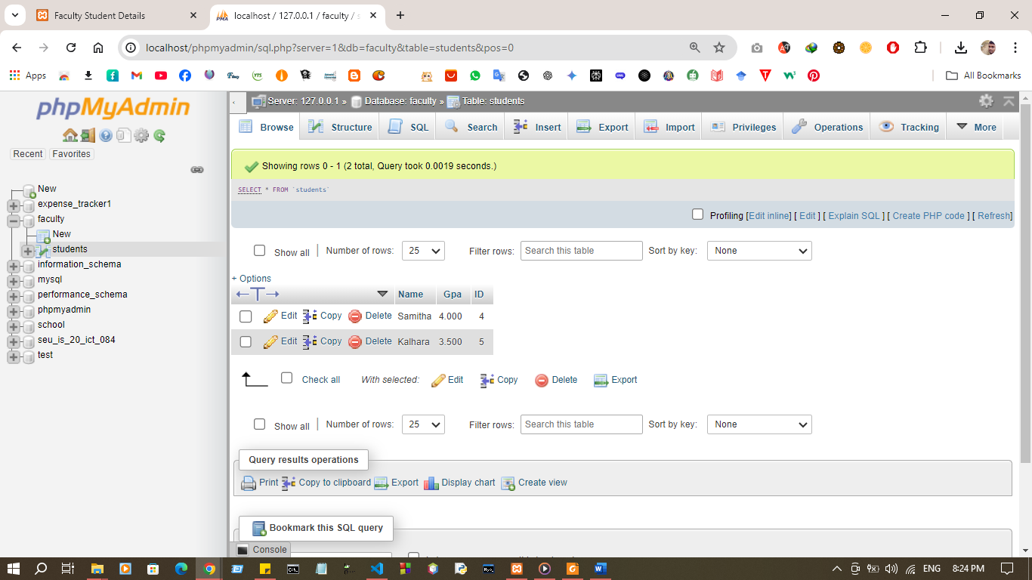

Exercise:
1. Create new database name as “todo”
2. Create new table “task”
3. That table contain id ( primary key ) , title and description.
4. Design a sample web page for this ToDo application using html and bootstrap.
5. Perform CRUD operation.
Code
Index.php

<?php
include('db.php');
require_once('todo.php');

$db = new Db("localhost", "root", "", "todo");
$db->connect();
$connection = $db->getConnection();

$todo = new Todo($connection);
$tasks = $todo->getAllTasks();

if ($_SERVER['REQUEST_METHOD'] === 'POST') {
$title = $_POST['title'];
$description = $_POST['description'];

$todo->setTitle($title);
$todo->setDescription($description);

if ($todo->create()) {
header('Location: index.php?success=Successfully added task');
exit();
} else {
header('Location: index.php?error=Failed to add task');
exit();
}
}

if (isset($_GET['id']) && isset($_GET['action'])) {
if ($_GET['action'] === 'delete') {
$task_id = $_GET['id'];
$todo->setId($task_id);
if ($todo->delete()) {
header('Location: index.php?success=Successfully deleted task');
exit();
} else {
header('Location: index.php?error=Failed to delete task');
exit();
}
} elseif ($_GET['action'] === 'update') {
$task_id = $_GET['id'];
// Redirect to update_task.php with the task ID
header('Location: update_task.php?id=' . $task_id);
exit();
}
}
?>

<!DOCTYPE html>
<html lang="en">
<head>
<meta charset="UTF-8">
<meta name="viewport" content="width=device-width, initial-scale=1.0">
<title>ToDo Application</title>
<link href="https://maxcdn.bootstrapcdn.com/bootstrap/4.5.2/css/bootstrap.min.css" rel="stylesheet">
</head>
<body>
<div class="container">
<h1 class="mt-5">ToDo List</h1>
<div class="card mt-3">
<div class="card-header">Add New Task</div>
<div class="card-body">
<form action="index.php" method="POST">
<div class="form-group">
<label for="title">Title:</label>
<input type="text" class="form-control" id="title" name="title" required>
</div>
<div class="form-group">
<label for="description">Description:</label>
<textarea class="form-control" id="description" name="description" required></textarea>
</div>
<button type="submit" class="btn btn-primary">Add Task</button>
</form>
</div>
</div>

<div class="card mt-3">
<div class="card-header">Tasks</div>
<div class="card-body">
<table class="table table-bordered">
<thead>
<tr>
<th>ID</th>
<th>Title</th>
<th>Description</th>
<th>Actions</th>
</tr>
</thead>
<tbody>
<?php foreach ($tasks as $task): ?>
<tr>
<td><?php echo htmlspecialchars($task['id']); ?></td>
<td><?php echo htmlspecialchars($task['title']); ?></td>
<td><?php echo htmlspecialchars($task['description']); ?></td>
<td>
<a href="index.php?id=<?php echo $task['id']; ?>&action=delete" class="btn btn-danger">Delete</a>
<a href="index.php?id=<?php echo $task['id']; ?>&action=update" class="btn btn-warning">Update</a>
</td>
</tr>
<?php endforeach; ?>
</tbody>
</table>
</div>
</div>
</div>
</body>
</html>
db.php
<?php
class Db {
private $host;
private $username;
private $password;
private $database;
private $connection;

public function __construct($host, $username, $password, $database) {
$this->host = $host;
$this->username = $username;
$this->password = $password;
$this->database = $database;
}

public function connect() {
$this->connection = mysqli_connect($this->host, $this->username, $this->password, $this->database);
if (!$this->connection) {
die("Connection failed: " . mysqli_connect_error());
}
}

public function getConnection() {
return $this->connection;
}
}
?>

todo.php

<?php
class Todo {
private $id;
private $title;
private $description;
private $connection;

public function __construct($connection) {
$this->connection = $connection;
}

public function getId() {
return $this->id;
}

public function getTitle() {
return $this->title;
}

public function getDescription() {
return $this->description;
}

public function setId($id) {
$this->id = $id;
}

public function setTitle($title) {
$this->title = $title;
}

public function setDescription($description) {
$this->description = $description;
}

public function create() {
if (empty($this->title) || empty($this->description)) {
die("Title and Description are required.");
}
$query = "INSERT INTO task (title, description) VALUES (?, ?)";
$stmt = mysqli_prepare($this->connection, $query);
mysqli_stmt_bind_param($stmt, 'ss', $this->title, $this->description);

if (mysqli_stmt_execute($stmt)) {
return true;
} else {
die("Failed to add task: " . mysqli_error($this->connection));
}
}

public function delete() {
if (empty($this->id)) {
die("ID is required.");
}
$query = "DELETE FROM task WHERE id = ?";
$stmt = mysqli_prepare($this->connection, $query);
mysqli_stmt_bind_param($stmt, 'i', $this->id);

if (mysqli_stmt_execute($stmt)) {
return true;
} else {
die("Failed to delete task: " . mysqli_error($this->connection));
}
}

public function update() {
if (empty($this->id) || empty($this->title) || empty($this->description)) {
die("All fields are required.");
}
$query = "UPDATE task SET title = ?, description = ? WHERE id = ?";
$stmt = mysqli_prepare($this->connection, $query);
mysqli_stmt_bind_param($stmt, 'ssi', $this->title, $this->description, $this->id);

if (mysqli_stmt_execute($stmt)) {
return true;
} else {
die("Failed to update task: " . mysqli_error($this->connection));
}
}

public function getAllTasks() {
$query = "SELECT * FROM task";
$result = mysqli_query($this->connection, $query);
if (!$result) {
die("Failed to retrieve data: " . mysqli_error($this->connection));
}
$tasks = [];
while ($row = mysqli_fetch_assoc($result)) {
$tasks[] = $row;
}
return $tasks;
}
}
?>

update_task.php

<?php
include('db.php');
require_once('todo.php');

$db = new Db("localhost", "root", "", "todo");
$db->connect();
$connection = $db->getConnection();

$todo = new Todo($connection);

if (isset($_GET['id'])) {
$task_id = $_GET['id'];
$todo->setId($task_id);
$query = "SELECT * FROM task WHERE id = ?";
$stmt = mysqli_prepare($connection, $query);
mysqli_stmt_bind_param($stmt, 'i', $task_id);
mysqli_stmt_execute($stmt);
$result = mysqli_stmt_get_result($stmt);
$task = mysqli_fetch_assoc($result);

if (!$task) {
die("Task not found!");
}
} else {
die("Invalid request!");
}

if (isset($_POST['id']) && isset($_POST['title']) && isset($_POST['description'])) {
$task_id = $_POST['id'];
$task_title = $_POST['title'];
$task_description = $_POST['description'];

$todo->setId($task_id);
$todo->setTitle($task_title);
$todo->setDescription($task_description);
$todo->update();
}
?>

<!DOCTYPE html>
<html lang="en">
<head>
<meta charset="UTF-8">
<meta name="viewport" content="width=device-width, initial-scale=1.0">
<title>Update Task</title>
<link href="https://maxcdn.bootstrapcdn.com/bootstrap/4.5.2/css/bootstrap.min.css" rel="stylesheet">
</head>
<body>
<div class="container">
<h1 class="mt-5">Update Task</h1>
<div class="card mt-3">
<div class="card-header">Update Task</div>
<div class="card-body">
<form action="update_task.php?id=<?php echo $task['id']; ?>" method="POST">
<input type="hidden" name="id" value="<?php echo htmlspecialchars($task['id']); ?>">
<div class="form-group">
<label for="title">Title:</label>

<input type="text" class="form-control" id="title" name="title" value="<?php echo htmlspecialchars($task['title']); ?>" required>

</div>
<div class="form-group">
<label for="description">Description:</label>

<textarea class="form-control" id="description" name="description" required><?php echo htmlspecialchars($task['description']); ?></textarea>

</div>
<button type="submit" class="btn btn-primary">Update Task</button>
</form>
</div>
</div>
</div>
</body>
</html>
sql.sql
CREATE DATABASE todo;
USE todo;

CREATE TABLE task (
id INT AUTO_INCREMENT PRIMARY KEY,
title VARCHAR(255) NOT NULL,
description TEXT NOT NULL
);

Output:
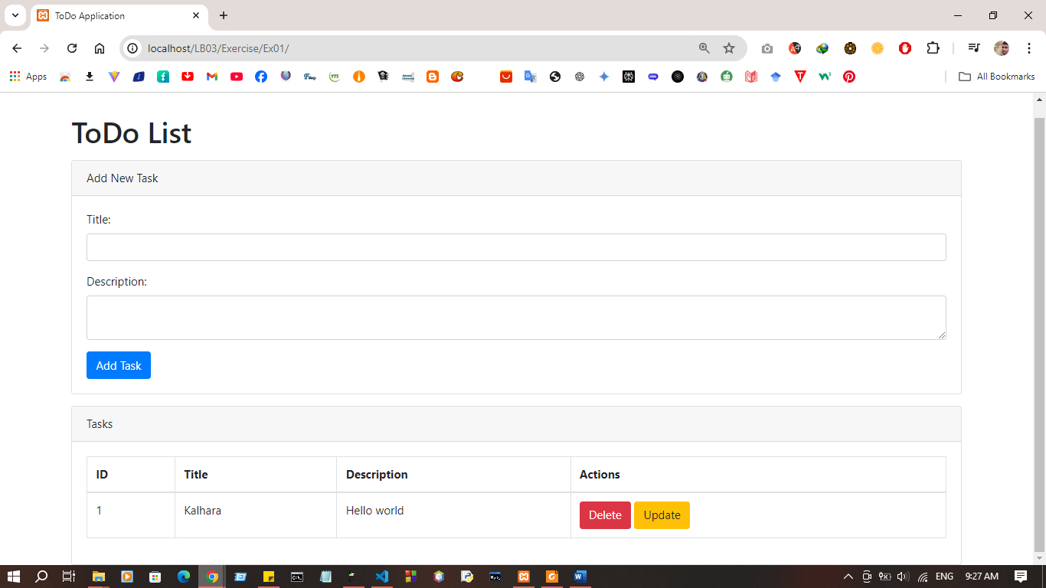
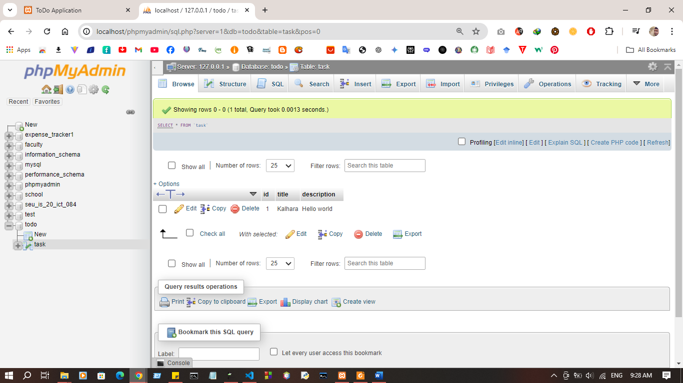

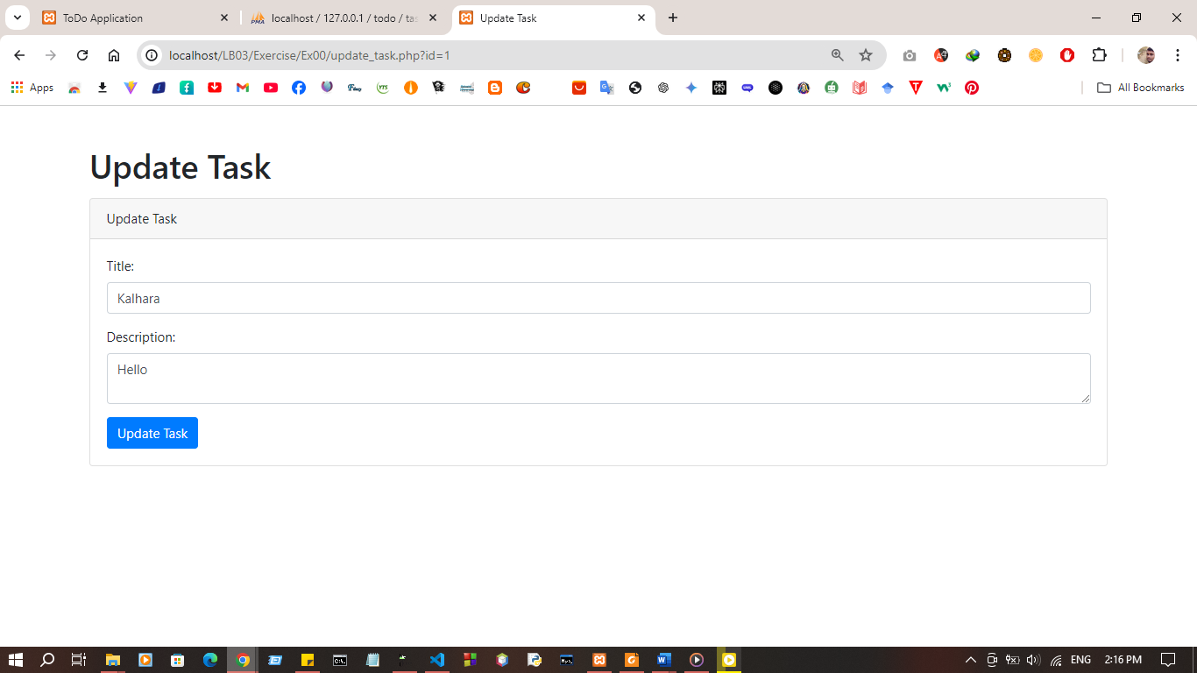

Discussion:
- In this practical session, the aim is to set up a MySQL database and work with it using PHP for performing basic CRUD (Create, Read, Update, Delete) operations. First, we begin by creating the MySQL database, which will serve as the storage for our data. After setting up the database, we establish a connection with PHP, allowing us to interact with the database programmatically. Using PHP, we then perform the Create operation, where data is stored in the database. Similarly, the Read operation is executed to retrieve and display data from the MySQL database using PHP queries. Next, the Update function is used to modify existing data entries, and finally, the Delete operation is carried out to remove unwanted data. This hands-on lab demonstrates the core functionality of PHP and MySQL integration, highlighting how these technologies work together to manage and manipulate data efficiently.

